GOES DCS Automatic Processing System (DAPS)
Summary and Purpose of Document
Over the past three months the USA has installed, acceptance tested, and has been running a parallel GOES DCS computer systems. By the end of October 1989 the new GOES DCS computer system or the DAPS will be made operational. The DAPS not only alleviates the limitations of the present computer system but also contains numerous features to improve overall DCS operations and management. This paper will present an overview to the DAPS.

Section 1. Introduction.
Development of the new DCS computer system or the DAPS began in late 1987. At that time the DAPS was to not only to alleviate the support limitations of the present GOES DCS Data Processing System (DPS) but also to improve overall GOES DCS operations, maintenance, and management. The DAPS, which is currently operating in parallel with the DCS/DPS computer system, has fulfilled the project's primary objectives and in some instances exceeded the initial design goals.
Figure 1 shows the GOES DCS with the new DAPS computer systems. The primary DAPS components are shown within the dashed lines. One major difference between the DAPS and the present DCS/DPS computer system is that all of its computer systems are located at the Wallops CDA station. By doing this NOAA/NESDIS has centralized GOES DCS maintenance activities and has eliminated dual dedicated telephone circuits between the Wallops CDA station and the World Weather Building (WWB) in Camp Springs, MD.
Aside from eliminating computer to computer the telephone circuits, the DAPS computer systems configuration is different. Instead of having two redundant computer systems situated at each facility operating independently. Although each DAPS computer maintains independent local DCP message data storage, the system employs two pairs of shadowed or mirrored disks for the GOES DCS centralized data bases and for global DCP message data storage. In this configuration either DAPS computer system can, via operational designation, have access to a common set of central DCS data base entries and DCP message data.
Figure 1 further shows that both DAPS computer systems are interconnected via a fallback switch. Although this switch can be manually activated for systems maintenance purposes, the DAPS is designed for automatic failover. In the event of a failure detected via the DAPS watchdog process, the system will automatically switchover control from the designated PRIME computer to the BACKUP computer. During an automatic switchover the PRIME'S interfaces are disabled and its mirrored disk access privileges are terminated. The DAPS then assigns the BACKUP system as PRIME, switches all of the operational interfaces, assigns mirrored disk access to the BACKUP, and re-establishes operator control. During the switchover process DCP data is being retained by Local Message Storage (LMS) resident on either computer. This data will be transferred to the designated PRIME computer as soon as the switchover process is complete. The DAPS accomplishes the switchover process in less than 90 seconds.
2.0 DAPS Operational Capabilities.
A functional layout of the DAPS is presented in Figure 2. This figure serves not only to identify key DAPS elements but also highlights the primary functions of the system.
1

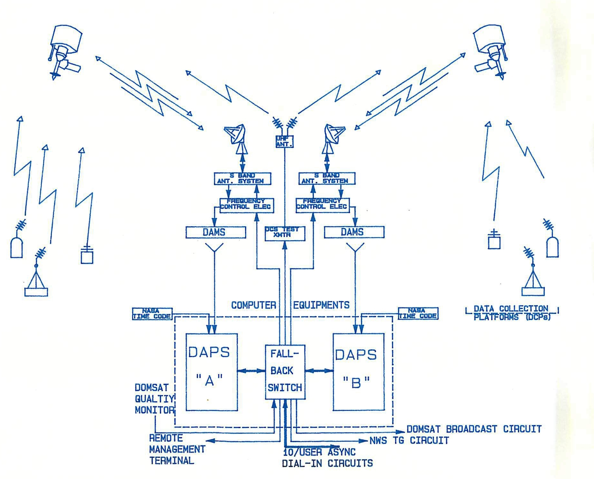

2

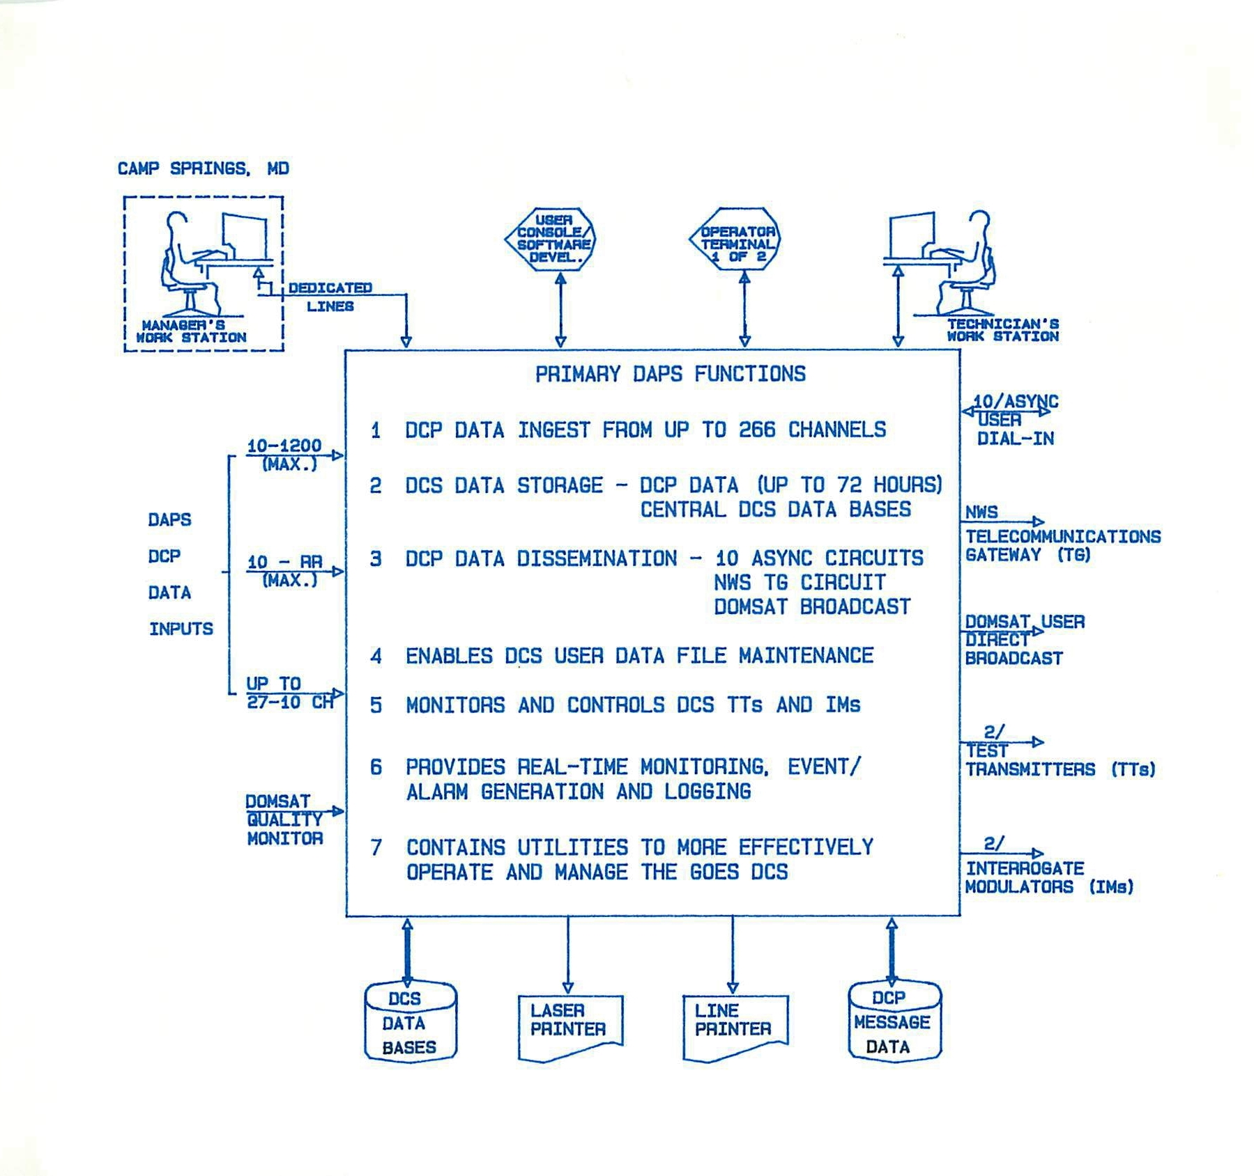

3

2.1 DCP Data Ingest.
The present DCS/DPS system can support up to 80 active 100 bps DCS channels. As figure 2 shows the DAPS has: 27-10 channel 100 bps or DAMS demodulator inputs; 10-1200 bps high data rate self-timed demodulator inputs, and 10-300 bps improved random reporting demodulator inputs. Given this configuration the DAPS can support the entire GOES DCS 400 kHz operating bandwidth or up to 266 active DCS channels in any input combination.
2.2 DCS Data Storage.
The DAPS contains data storage for not only DCP message data but also for the central GOES DCS data bases. Under DAPS each computer system maintains up to 24 hours of DCP Local Message Storage (LMS) and either system has access to Global Message Storage (GMS) maintained in duplicate form on a mirrored disk pair. The GMS DCP message data storage is sized to accommodate 72 hours of data at a one million messages per day load. Therefore, an operational DAPS computer system contains up to three sources of DCP message data thus minimizing DCP data loss.
A second DAPS mirrored disk pair is dedicated to storage of the central GOES DCS data bases. The data bases contained on this mirrored pair include: the Platform Data Table (PDT) containing up to 100,000 entries or DCPs, the User Data Table (UDT) containing up to 5000 user accounts, and the Memorandum of Agreement (MOA) table containing up to 5000 records. Given that the present DCS/DPS computer system supports only 9000 PDT entries and only 256 UDT entries. Aside from data storage the DAPS is sized to handle a 30,000 active DCP load. The DCS/DPS presently can handle 6000 active DCPs. Hence, the DAPS represents a considerable upgrade.
2.3 DCP Data Dissemination.
The DAPS disseminates DCP message data via three different operational interfaces - any one of the 10 async user dial-in circuits, a dedicated NWS Telecommunications Gateway (TG) circuit, and a dedicated DOMestic SATellite (DOMSAT) broadcast circuit.
The DAPS dial-in message dissemination interface was designed to support the relatively small DCS user (< 50 DCPs) . The DAPS asynchronous circuits are serviced by modems which auto-adjust the interconnect data rate at either 300, 1200, or 2400 bps and the provide error correction via the Microcom Network Protocol at user signon depending upon the user's local terminal characteristics. The DAPS user async software enables the operator to select the number of messages per dissemination and the number of disseminations permitted on a daily basis. At present these parameters are set at 2000 per dissemination and 12 per day. DAPS DCP message dissemination is via the DCP address obtained via either entering the desired address
4

manually or via a pre-defined User Network List (UNL) . Each user may have up to five UNLs in the DAPS. UNL dissemination is generally automatic in that the DAPS will download all message data for DCPs within the UNL since the last UNL retrieval. The user can preempt this feature by specifying dissemination time fields if they desire.
Another major difference between the DAPS and the DCS/DPS is that any DCP message can be redistributed without restriction to the same user or any other systems user for up to 72 hours. Under the DCS/DPS once a message was sent out to the specified user, that user could not routinely receive a second or retransmission of that message.
The DAPS NWS TG circuit is routed from the Wallops CDA station in Virginia to the NWS TG facility in Suitland, MD. This circuit operates at a 4800 bps data rate under the TG's X.25 protocol definition. The primary differences between the DAPS NWS circuit and the present DCS/DPS NWS circuit are its X.25 protocol versus BISYNC, new routing descriptors, and that all bulletins are transmitted to the NWS TG only once. Aside from the new data descriptors, GOES DCS NWS TG users will receive DCP message data in an identical format to that supported by the DCS/DPS NWS circuit.
Another difference between the DAPS and the DCS/DPS is the addition of the DOMSAT direct broadcast circuit. The DOMSAT circuit operates at a 56 kbps data rate using a simplex X.25 packet format and processes the entire DCP message data load. In essence the DAPS transmits all DCP messages via DOMSAT in real-time. To maintain the integrity of the DOMSAT communication link the DAPS has monitoring input referred as the DOMSAT Quality Monitor (DQM). The DQM constantly monitors each DCP message’s: cyclical redundant checksum, packet sequence number, and message sequence number. Should a problem be detected it is reported to the DAPS computer.
Given the real-time distribution capabilities of the DOMSAT, it is considered the primary DAPS DCP message dissemination circuit. To encourage DCS users to use the new circuit, the DAPS project also included the development of a DOMSAT Receive Only Terminal (DROT). The DROT consists of a 386 based Personnel Computer (PC), containing 4 MB of RAM storage, a 66 MB Winchester hard disk, and an off-the-shelf X.25 communication board. The DROT's operating system software is Microsoft ZENIX. In essence the DROT strips off the DAPS X.25 packet structure, stores DCP message data for up to 1600 DCP addresses in real-time onto its hard disk. The structure of a DCP message after the X.25 structure is removed is identical to that of the async dial-in. The DROT can serve as a "bent pipe" into a users large computer systems via its RS-232 output port which supports data rates of up to 19.2 kbps.
Another feature of the DAPS for DOMSAT dissemination users is the ability to request a retransmission of their pre-defined DCP data. This is accomplished via a retransmit command for which
5

either a DCP address is identified or via a UNL is designated. User retransmission requests are serviced on an as available basis based upon a DAPS pre-defined priority retransmit software.
2.4 DCS Data Base Management
Although the present DCS/DPS enables the DCS users to update or edit their PDT entries, in general the maintenance of these data files is performed by NOAA/NESDIS. Under DAPS the maintenance of the PDT entries and the UDT entries will be the responsibility of each DCS user. Should the PDT entry be incorrect or incomplete, the DAPS will issue an Abnormal Response Message (ARM) each time this situation is detected. Therefore every user of the improperly DCP will receive ARMs that apply to the. DCP every time an error condition is detected. Although UDT file maintenance is not monitored by the DAPS, NOAA/NESDIS intends to use the address(s) and personnel identified in the UDT for mailing and administrative purposes.
2.5 DCS Test Transmitters (TTs) and Interrogate Modulator (IMs)
The DAPS monitors and controls the operation of two DCS TTs and two DCS IMs. The DAPS controls the old DCS TT and a new enhanced DCs TT. The old GOES DCS test transmitter is designed such that it can transmit on any GOES DCS channel manually via operator command or automatically via the DAPS. When commanded the DCS 100 bps test transmitter sends a message to the satellite. The resulting message is then received, verified, and checked by the DAPS. If a message is received in error or not received, an error is posted. The DAPS uses the old TT to check each active DCS channel every two hours and insures that all active DCS receive channels are functioning properly. In the automatic mode the DAPS is designed not to interfere with DCPs operating on self-timed channels. The second or enhanced DCS TT has advanced capabilities to test the new high data rate DCS channels and to be used for channel blocking activity via the DAPS. If a DCP is detected to be operating unofficially in the system, NESDIS operations management are able to detect this event and issue an automatic blocking command to inhibit the DCP owner from receiving any useful GOES DCS data.
As with the present DCS/DPS, the DAPS monitors and controls the operation of an East GOES and a West GOES interrogate modulator. In essence the DAPS prepares an interrogate schedule from the PDT data base entry. At the approximate time the DAPS will transfer the appropriate DCP address to the DCS interrogate modulators from which these signal are uplinked to the GOES spacecraft. After issuing the interrogation the DAPS searches for the respective interrogate response. If no response results a re-interrogation is posted. Should all re-interrogation attempts be exhausted error messages are posted. In the event of no pending interrogations the DAPS sends the DCS "dummy"
6

address to the interrogate modulators at half second intervals.
Other special interrogate link features supported by the DAPS include: the auto-interrogate of a self-timed DCP that fails to report and the transmission of a special trigger address over the interrogate link in response to receipt of a DCP special trigger message.
2.6 DAPS Real-time Monitoring, Event/Alarm Generation and Logging.
The DAPS contains numerous real-time systems monitoring capabilities. The monitoring capabilities include: errant DCP operations, DCS channel operations, test transmitter or interrogate modulator failures, NWS TG circuit status, DOMSAT circuit status, critical system processes, etc. For each of the items identified above, the DAPS operator is provided the ability to declare a detected error as either a systems event or a systems alarm. Should any item be considered a systems alarm it will appear on the bottom three lines of all active DAPS computer systems terminals. It may also depending upon the operators discretion sound an audio alarm.
Aside from the operator's ability to classify systems errors as events or alarms, the operator can also set a parameter for each event/alarm which controls the frequency of consecutive errors reported prior to alerting the operator to an alarm or recording the malfunction or event to the log. Although this features appears to mask problems, it merely alleviates the operators duties should a problem persist. For very persistent problems the operator may disable entire DAPS alarm/event reporting of the event. This feature extends to disabling all reporting for a malfunctioning demodulator or DCS channel, demodulator drawer of up to 10 channels, or even an entire GOES spacecraft. It should be noted that in using this feature only the reporting of the error is masked, the DAPS still maintains statistics of each problem as per the actual frequency of occurrence.
For DAPS error events involving a individual DCPs (e. g. a self-timed reporting out of its assigned time slot), the DAPS detects the event upon ingest and issues an ARM describing the malfunction. As with the present DCS/DPS, ARMs are included with the DCP message data received during the event and are disseminated to the respective DCS user(s).
2.7 DAPS Management Utilities
The DAPS contains utilities to assign and schedule DCPs; to monitor channel and system utilization; and to prepare DCS management reports with supporting graphics, charts, tables, etc. DAPS management activities can. be performed either via the remote manager terminal in Camp Springs, MD or via the DAPS technician workstation at the Wallops CDA station. A brief explanation of each of these utilities is presented below.
7

2.7.1 DCP Assignment Utilities. The DAPS assignment utilities allow the addition or the updating of DCPs in the PDT. Additions or updates to the DCS PDT can be performed in either an interactive and batch mode. To assist the manager in making assignments or updates the DAPS contains routines that will check the channel¹ s time slot assignments, that check for the validity of the DCP type (interrogate, self-timed, random, dual) given the DCS channel assignment, and that insure the manager has properly entered all PDT fields prior to the systems acceptance of the new or revised entry.
To further assist the DCS systems manager the DAPS contains a DCP look angle utility. The DCP look angle utility is available in the event of spacecraft repositioning. Should the GOES be moved the utility will identify how many DCPs might be adversely impacted. The utility can, if the manager desires, provide a hard copy of the effected DCP addresses. Aside from GOES relocation, the DCP look angle utility can also provide specific azimuth and elevation information regarding a DCP's antenna pointing.
2.7.2 DAPS Reporting Capabilities. The DAPS routinely prepares numerous DCS management reports. The major management reports focus upon DCS channel activity, DCP performance at selected intervals, and DCS user utilization. The monthly DCP performance summary reports are also available to the respective DCS users via the async dial-in interface. The DAPS compiles the statistical data for each of these reports in real-time and reduces these data in a pre-defined algorithm format.
2.7.3 DAPS Data Base Management System (DBMS) . The DAPS contains a DBMS. As indicated earlier the DBMS can enable the manager to perform major DCS changes. It also, permits ad hoc queries on any data base entry, field or Boolean combinations. In some instances these queries can be displayed and hard copied into line, bar, and pie charts for presentation to DCS users and for a more effective DCS operational presentation.
2.7.4 DAPS Map Generation. The DAPS contains the ability to provide a map projection of DCPs located within the GOES footprints. The resolution of the maps can be focused upon a specific geographical area, a specific DCS user, or any combination provide via the DAPS DBMS.
8

